DIS-AM,C-Taino-Three-pointed stone-Fewkes Type 3

Three-pointed stone-Fewkes Type 4, fine grained basalt, 8''1/4  long, 5'' in height and 3'' 1/4 base. weight 6 pounds. from The Dominican Republic. God of fertility. "Spirit of the Yucca and the sea. It was buried in the conucos cassava; main food of the native Taino, to fertilize the soil. This type with the image of the deity on top facing upwards is the rarest of the Three-pointed sculptures. Less than ten have been found.

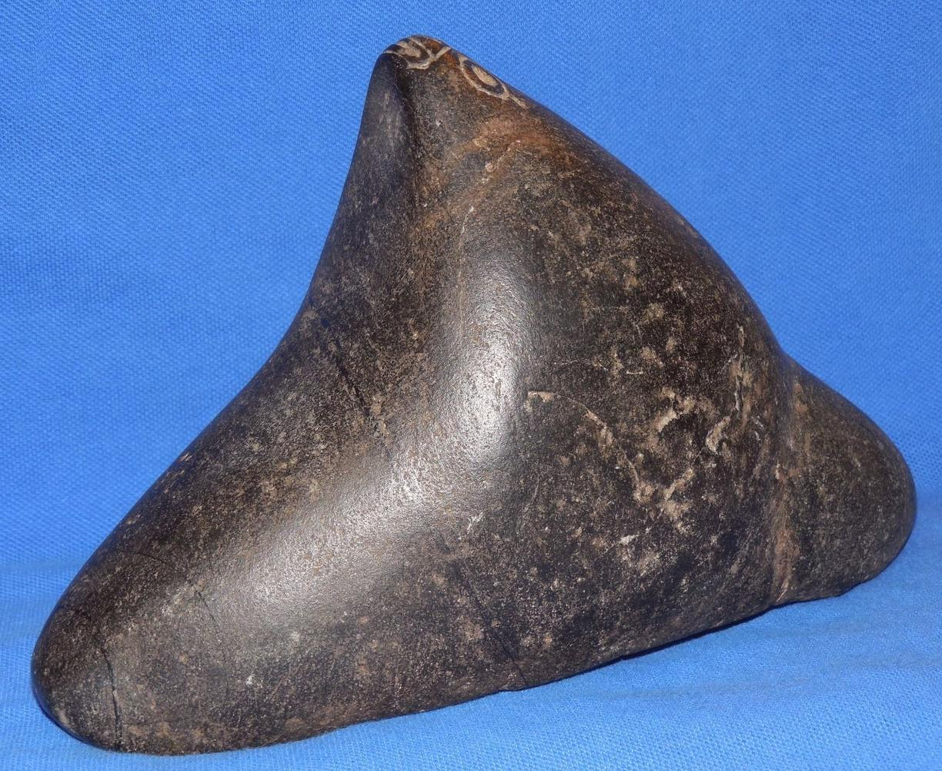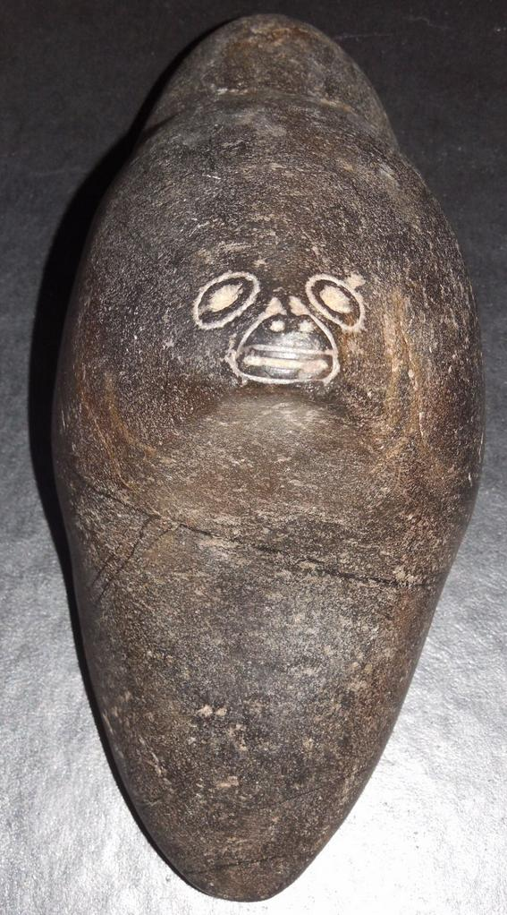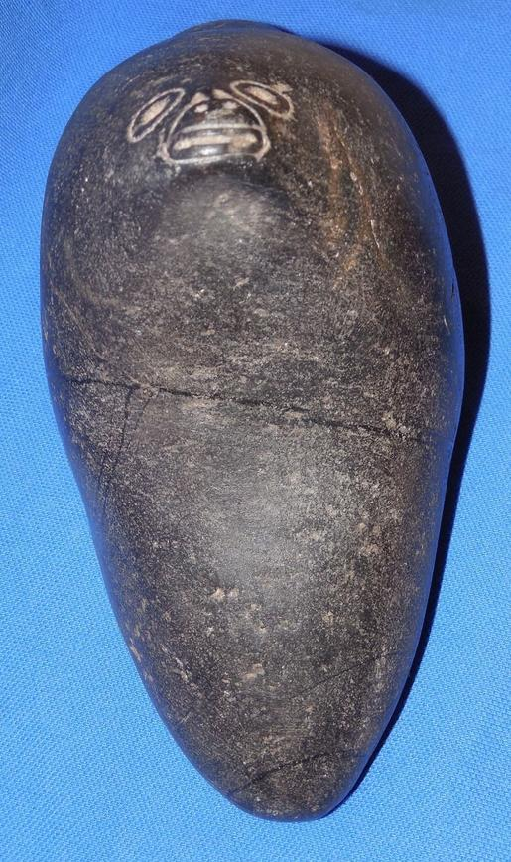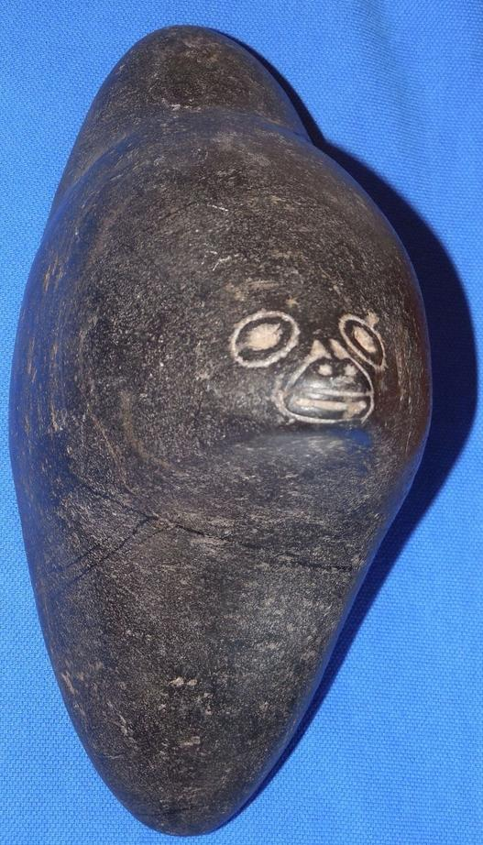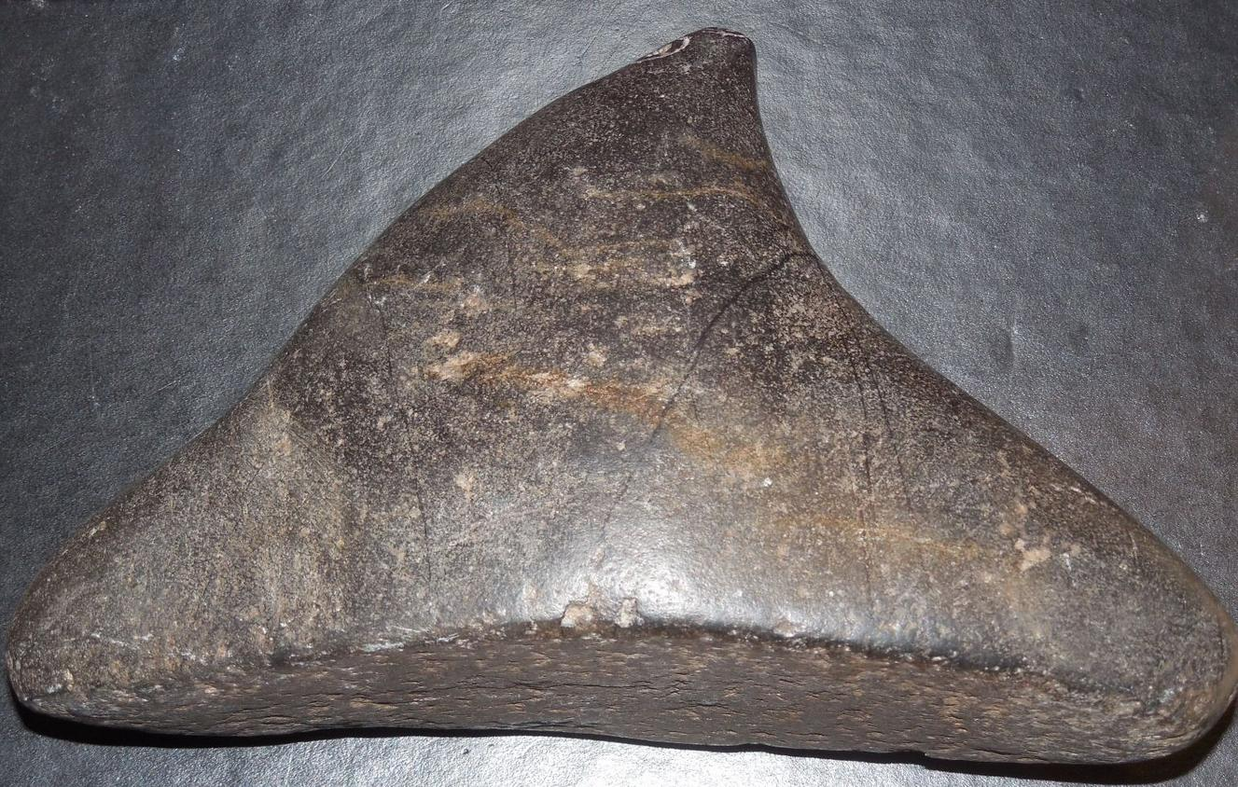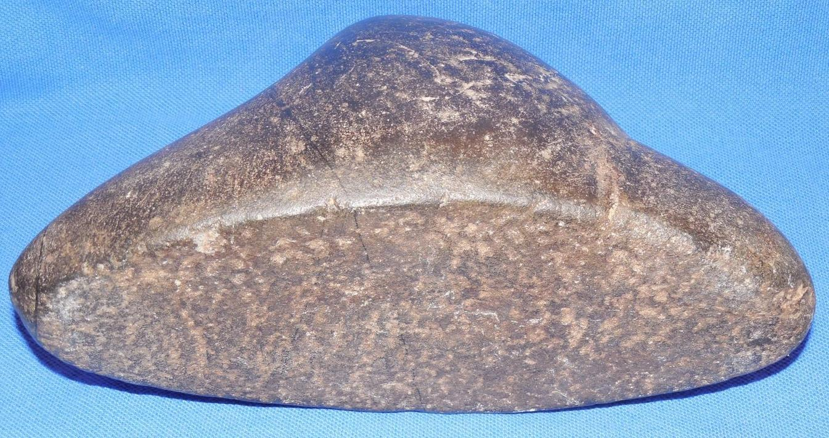

### Delivery package 1 of 1

Estimated delivery Saturday, Mar 19, 2016

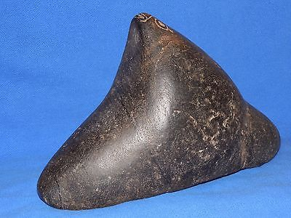

#### [TAINO PRE-COLUMBIAN BLACK STONE TRI- POINTER](http://www.ebay.com/itm/262320838223)

|  |  |
| --- | --- |
| Item price | $299.00 |
| Quantity | 1 |
| Item number | 262320838223 |
| Shipping service | USPS Priority Mail |

## Shipping address

Ralph J Coffman Jr

149 Atlantic Ave

Swampscott MA 01907-2427

United States

## Order total

|  |  |
| --- | --- |
| Subtotal | $299.00 |
| Shipping | $10.00 |

**Total**

$309.00

Order placed on

Saturday, Mar 12, 2016

Payment method

PayPal

Payment date

Saturday, Mar 12, 2016